Comp1804 Report
23-03-2024

Word Count excluding Table of Contents, Table of Figures and References: 2469

Table of Contents
Executive Summary 4
1. Data Exploration and Assessment 4
2. Data Cleaning and Splitting 6
3. Data Encoding 8
4. Task 1 – Topic Classification 8
4a. Model Building 8
4b. Model Evaluation 9
4c. Task 1 Conclusions 11
5. Task 2: Text Clarity Classification Prototype 12
5a. Ethical Discussion 12
5b. Data Labelling 12
5c. Model Building and Evaluation 13
5d. Task 2 Conclusions 15
6. Self-Reflection 16
7. References 17

Table of Figures
Figure 1. Shape of the dataset 4
Figure 2. Columns of the dataset 4
Figure 3. Data types 5
Figure 4. Identification of null values in the dataset 5
Figure 5. Distribution of category features before cleaning 6
Figure 6. Removal of null values from the dataset 6
Figure 7. Category features after preprocessing 7
Figure 8. Distribution of category features after preprocessing 7
Figure 9. Class distribution before sampling 8
Figure 10. Class distribution after sampling 8
Figure 11. Classification report of the Logistic Regression Classifier with hyperparameter optimization for task 1 9
Figure 12. Confusion matrix of the Logistic Regression Classifier with hyperparameter optimization for task 1 10
Figure 13. Classification report of the Random Forest Classifier with hyperparameter optimization for task 1 10
Figure 14. Confusion matrix of Random Forest Classifier with hyperparameter optimization for task 1 11
Figure 15. Classification report of the Logistic Regression Classifier with hyperparameter optimization for task 2 13
Figure 16. Confusion matrix of Random Forest Classifier with hyperparameter optimization for task 2 14
Figure 17. Classification report of the Random Forest Classifier with hyperparameter optimization for task 2 14
Figure 18. Confusion matrix of Random Forest Classifier with hyperparameter optimization for task 2 15

Executive Summary
The main objective of this study was to classify the topic and text clarity by applying the concept of text classification. In the topic classification task, the obtained accuracy of the logistic regression classifier model was 93% with hyperparameter optimization. The model has satisfied the trivial base of less than 10% mismatched results across all classes. Furthermore, the random forest model was used for the text clarity classification task with hyperparameter optimization, and the acquired training and testing accuracy was 84% and 86% respectively which satisfies the requirement of the client successfully.

Data Exploration and Assessment
Firstly, the shape of the dataset was checked as in Figure 1 which shows the shape as (9347,8). This means that the number of columns in the dataset was 8 and the number of rows was 9347.

Figure 1. Shape of the dataset
Then, the columns in the dataset was checked and the resulting indexes are a unique identifier for each paragraph to classify namely ‘par_id’, text to classify namely ‘paragraph’, text to check a reference to product/organization/person namely ‘has_entity’, number of words in the text namely ‘lexicon_count’, number of difficult words namely ‘difficult_words’, gender of the person who edited at the latest namely ‘last_editor_gender’, category into which the text should be classified namely ‘category’ and clarity level of the text namely ‘text_clarity’ as in Figure 2.
Figure 2. Columns of the dataset
This dataset was a mixture of categorical and numerical features in which ‘paragraph’, ‘has_entity’, ‘last_editor_gender’, ‘category’ and ‘text_clarity’ were categorical variables with object data type whereas ‘par_id’, ‘lexicon_count’ and ‘difficult_word’ were numerical variables with integer (int64) and floating (float64) data types as in Figure 3.
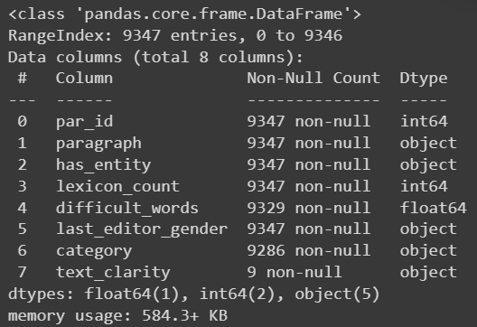
Figure 3. Data types
After that, the existence of null values in the dataset was checked as in Figure 4 and found that there were 18 null values in ‘difficult_words’ and 61 null values in ‘category’. 9338 null values in the ‘text_clarity’ were task-specific null values, which was mandatory for task 2.
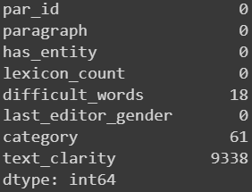
Figure 4. Identification of null values in the dataset
Then, the distribution of paragraphs in the category features was checked out and the resulting values for ‘biographies’, ‘artificial intelligence’, ‘programming’, ‘philosophy’, ‘movies about artificial intelligence’, ‘Philosophy’, ‘Programming’, ‘Artificial intelligence’, ‘Biographies’ and ‘Movies about artificial intelligence’ were 2942, 1565, 1980, 2585, 166, 13, 10, 11, 13 and 1 respectively. The mismatched values in the category features were visible as in Figure 5.
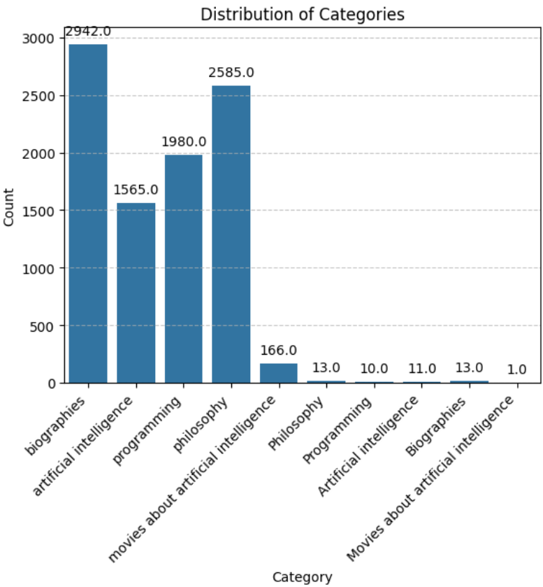
Figure 5. Distribution of category features before cleaning

Data Cleaning and Splitting
Now, in the data cleaning process, the ‘par_id’ column was dropped from the dataset because it did not contain any useful information. The null values found in the ‘difficult_word’ and ‘category’ features was dropped from the dataset instead of refilling with the most occurred value because the null value count was low compared to the total count in those features to have any effect even if removed [Refer to Figure 6].
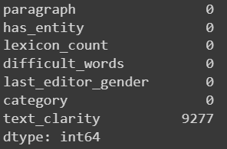
Figure 6. Removal of null values from the dataset
Now, all the variables in the category column were converted to lowercase as in Figure 7, making it unique to solve the mismatched value problem by treating the lowercase and uppercase at the same time.
Figure 7. Category features after preprocessing
After the preprocessing of ‘category’ features, distributions of count had changed to ‘biographies’, ‘artificial intelligence’, ‘programming’, ‘philosophy’ and ‘movies about artificial intelligence’ having 2955, 1576, 1990, 2598 and 167 respectively as in Figure 8.
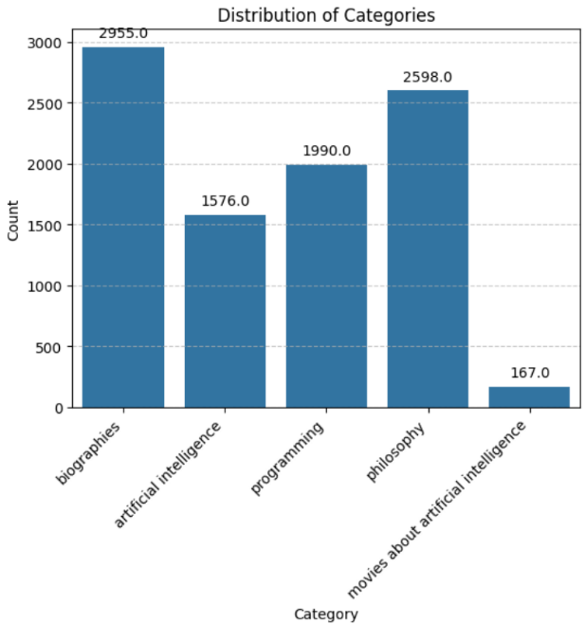
Figure 8. Distribution of category features after preprocessing
For the topic classification, the features ‘paragraph’ and ‘has_entity’ was taken as input and label ‘category’ was taken as output. Then, the dataset was split into train and test sets using a ratio of 80% for training and the remaining 20% for testing. Then, the ‘paragraph’ column was converted to lower case for train and test data. Then, ‘paragraph’ and ‘has_entity’ was taken as feature selection for both train and test data. Finally, label encoding was done on ‘category’ column for train and test data.
For the text clarity classification, labels were defined in the ‘text_clarity’ column using certain criteria mentioned in Section 5b. Then, the ‘paragraph’ column was converted to lower case and processed the data in it using CountVectorizer. Then, label encoding was done on ‘text_clarity’ column. Now, the feature ‘paragraph’ was taken as input and label ‘text_clarity’ was taken as output. Then, the dataset was split into train and test sets using a ratio of 80% for training and the remaining 20% for testing.

Data Encoding
TF-IDF Vectorization was carried out to vectorize each paragraph. The TfidfVectorizer with a maximum of 5000 features was selected for the reduction of computational complexity by reducing the size of vocabulary. These vectorized data was standardized using StandardScaler.
When values of each category were checked, the class was imbalanced [Refer to Figure 9]. SMOTE sampling strategy was applied for handling over sampling and RandomUnderSampler was applied for handling under sampling to balance the existing class distribution. These two samplers were combined in a pipeline and applied to the TF-IDF features. The result of the sampled class distribution was 2333 for each class as in Figure 10, referring 0 to ‘artificial intelligence’, 1 to ‘biographies’, 2 to ‘movies about artificial intelligence’, 3 to ‘philosophy’ and 4 to ‘programming’.
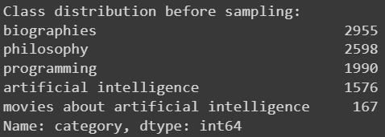
Figure 9. Class distribution before sampling
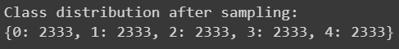
Figure 10. Class distribution after sampling

Task 1 – Topic Classification

4a. Model Building
In topic classification, two models have been developed which are Logistic Regression Classifier with hyperparameter optimization and Random Forest Classifier with hyperparameter optimization.
For the Logistic Regression with hyperparameter optimization, the grid search using the ‘GridSearchCV’ was performed for C including [0.001, 0.01, 0.1, 1, 10, 100] through the utilization of 5-fold cross-validation.
For the Random Forest Classifier with hyperparameter optimization, the grid search using the ‘GridSearchCV’ was performed for ‘n_estimators’ checking number of trees within [100, 200, 300] range, ‘max_depth’ checking maximum number of levels within [10, 20, 30, None] range, ‘min_samples_split’ checking minimum number of samples required to split internal node within [2, 5, 10] range and ‘min_samples_leaf’ checking minimum number of samples needed to be at leaf node within[1, 2, 4] range (sklearn.ensemble.RandomForestClassifier, no date).
From Table 1 and Table 2, the best parameter for both the model was checked and the obtained optimal value for ‘C’ was 0.01 for Logistic Regression Classifier and ‘max_depth’ was None, ‘min_samples_leaf’ was 1, ‘min_samples_split’ was 5 and ‘n_estimators’ was 300 for Random Forest Classifier.
Logistic Regression Classifier Hyperparameter | Optimal Value
C | 0.01
Table 1. Best hyperparameter value for Logistic Regression Classifier
Random Forest Classifier  Hyperparameter | Optimal Value
max_depth | None
min_sample_leaf | 1
min_samples_split | 5
n_estimators | 300
Table 2. Best hyperparameter value for Random Forest Classifier

4b. Model Evaluation
Figure 11 represents the classification report of the logistic regression classifier model with hyperparameter optimization. The overall accuracy obtained from the model with hyperparameter optimization is 0.93. The F1-score across category classes was artificial intelligence (0.90), biographies (0.94), movies about artificial intelligence (0.93), philosophy (0.91) and programming (0.95) respectively, indicating high accuracy across category classes.
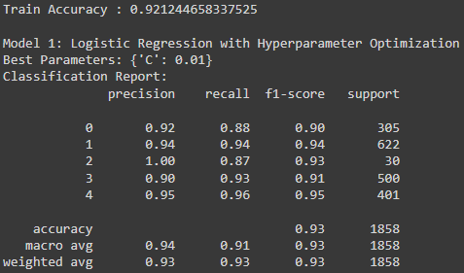
Figure 11. Classification report of the Logistic Regression Classifier with hyperparameter optimization for task 1
Figure 12 indicates the confusion matrix of the logistic regression classification model with hyperparameter optimization, providing a visual representation of the overall classification performance of the model across different classes. The number of true positive cases across all classes was highlighted in the confusion matrix. From Figure 17, the number of true positive classifications across the 5 category classes was artificial intelligence (268), biographies (583), movies about artificial intelligence (26), philosophy (466) and programming (384) respectively.
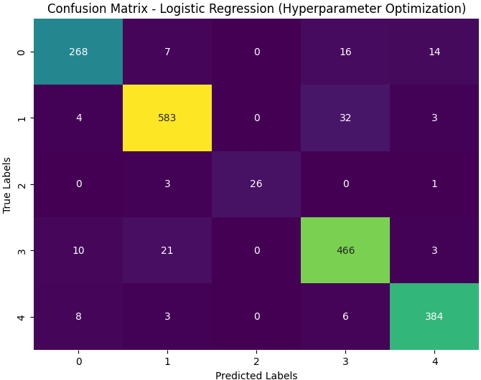
Figure 12. Confusion matrix of the Logistic Regression Classifier with hyperparameter optimization for task 1
Figure 13 represents the classification report of the random forest classifier model with hyperparameter optimization. The overall accuracy obtained from the model with hyperparameter optimization was 0.85 and the F1-score across category classes was artificial intelligence (0.76), biographies (0.88), movies about artificial intelligence (0.38), philosophy (0.82) and programming (0.91) respectively.
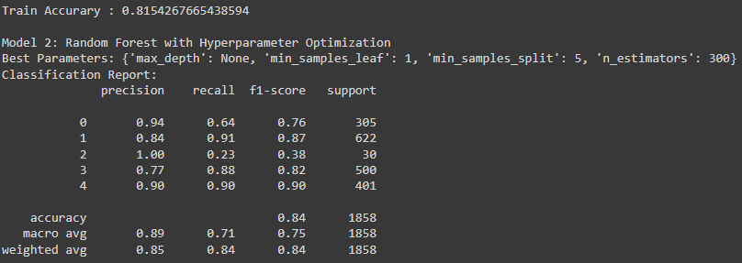
Figure 13. Classification report of the Random Forest Classifier with hyperparameter optimization for task 1
Figure 14 indicates the confusion matrix of the random forest classifier model with hyperparameter optimization, providing a visual representation of the overall classification performance of the model across different classes. The number of true positive cases across all classes was highlighted in the confusion matrix. The number of true positive classifications across the 5 category classes was artificial intelligence (194), biographies (563), movies about artificial intelligence (7), philosophy (444) and programming (370) respectively.
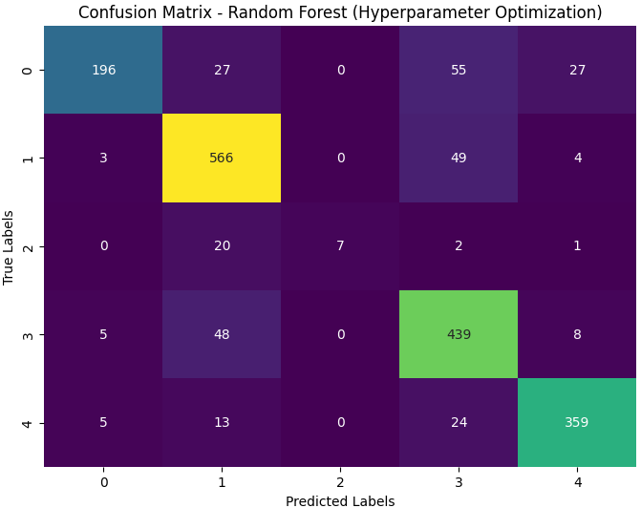
Figure 14. Confusion matrix of Random Forest Classifier with hyperparameter optimization for task 1
The training and testing accuracy was compared for each model. From Table 3, the training accuracy (0.92) and testing accuracy (0.93) of the Logistic Regression Classifier model with hyperparameter optimization is the highest among all the developed models.
Parameters | Logistic Regression Classifier with hyperparameter optimization | Random Forest Classifier with hyperparameter optimization
Training Accuracy | 0.92 | 0.81
Testing Accuracy | 0.93 | 0.85
Table 3. Model Comparison of Task 1

4c. Task 1 Conclusions

- The logistic regression classifier model with hyperparameter optimization had obtained a classification accuracy of approximately 93%, fulfilling the trivial baseline of less than 10% misclassified category without underfitting. Therefore, the developed model can be considered as successful and NotTheRealWikipedia can use this model for classifying the topic.
- The client can consider the F1 score as the performance metric for monitoring the performance of the classification model as it has the capability to capture the accuracy of the model across all category classes.

Task 2: Text Clarity Classification Prototype

5a. Ethical Discussion
The automatic rejection of the work of the user based on the outcome of the classification model can cause different ethical concerns such as violation of data integrity and model biases in the decision-making process. The main complications and ethical challenges associated with machine learning-based classification models are the unethical handling of data along with violation of data integrity, leading to the formulation of inaccuracy in the classification results. In addition to that, the exclusion of contextual background in the paragraph and solely predicting the clarity of the paragraph based on lexicon count and the number of difficult words can lead to inaccuracy in the system as contextual background sometimes defines the clarity of the paragraph. This can create mistrust among the users, leading to reduced satisfaction levels among the users (Lo Piano, 2020).

5b. Data Labelling
The labelling criteria for categorizing the ‘text_clarity’ column into two main classes, are clear_enough and not_clear_enough. A subset of the dataset has been considered to help reduce the computational complexity filling the whole data points with criteria.
Labelling criteria:
- clear_enough: Paragraphs consisting of lexicon count between 45 and 120 and difficult words of less than 50 were labelled as “clear-enough”. The reason for this condition was that the already given 9 data points were satisfying those criteria.
- not_clear enough: Paragraphs consisting of lexicon count of less than 45 and more than 120 and difficult words of more than 50 were labelled as “not_clear-enough”. The reason was the same as mentioned above.
This updated dataset was saved into a new excel sheet called “task2_dataset.csv”

text_clarity | Labelled data points | Example
clear_enough | 3687 | Kant named the example of a thirsty person the Hypothetical Imperative. Kant used the hypothetical imperative to explain his ideas about the ethics of a categorical imperative. For example, it is not usually a moral choice when a person decides to drink water, no matter why they are drinking the water. If a person is very thirsty, then it is a hypothetical imperative that they drink the water.
not_clear_enough | 5100 | Hamilton, W.; Zuk, M. . "Heritable true fitness and bright birds: A role for parasites?". Science. 218 : 384â€“387. Bibcode:1982Sci...218..384H. doi:10.1126/science._PHONE_. PMID _PHONE_. S2CID _PHONE_. In this phase people also stop believing in the idea of immanent justice.
Table 4. Labelled data points

5c. Model Building and Evaluation
For text clarity classification, two models were developed which are Logistic Regression Classifier with hyperparameter optimization and Random Forest Classifier with hyperparameter optimization.
For both the classifiers, the same hyperparameters were used as mentioned in Section 4a.
Figure 15 represents the text clarity classification report of the logistic regression classifier model with hyperparameter optimization. The training and testing accuracy obtained from the model was 0.58 and 0.59 respectively. The F1-score across category classes was 0.45 for ‘clear_enough’ and 0.68 for ‘not_clear_enough’.
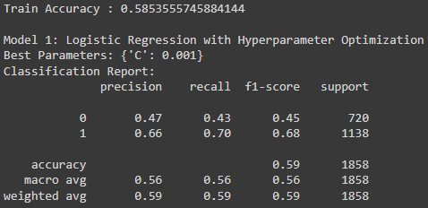
Figure 15. Classification report of the Logistic Regression Classifier with hyperparameter optimization for task 2
The number of true positive cases across all classes was highlighted in the confusion matrix. From Figure 21, the number of true positive classifications across both classes was 310 for clear_enough and 799 for not_clear_enough [Refer to Figure 16].
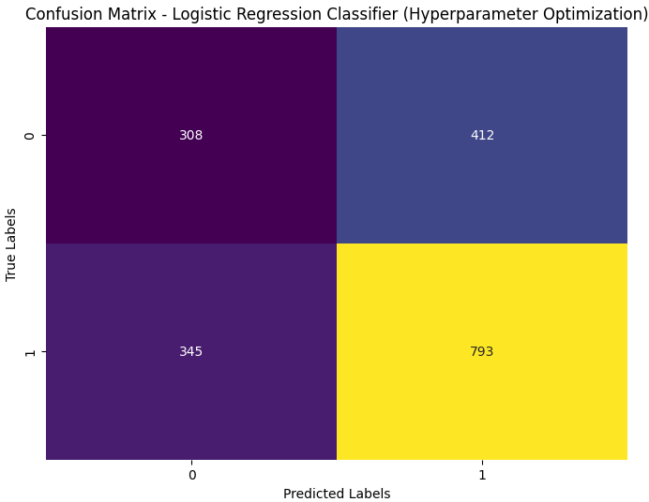
Figure 16. Confusion matrix of Random Forest Classifier with hyperparameter optimization for task 2

Figure 17 represents the text clarity classification report of the random forest classifier model with hyperparameter optimization. The training and testing accuracy obtained from the model was 0.84 and 0.86 respectively. The F1-score across category classes was 0.80 for ‘clear_enough’ and 0.89 for ‘not_clear_enough’.
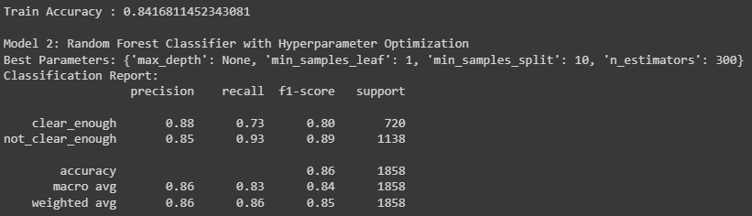
Figure 17. Classification report of the Random Forest Classifier with hyperparameter optimization for task 2
The number of true positive cases across all classes was highlighted in the confusion matrix. From Figure 21, the number of true positive classifications across both classes was 527 for ‘clear_enough’ and 1063 for ‘not_clear_enough’ [Refer to Figure 18].
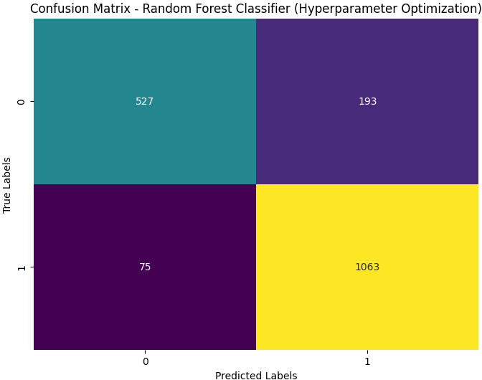
Figure 18. Confusion matrix of Random Forest Classifier with hyperparameter optimization for task 2
Based on the classification accuracy of developed models, the Logistic Regression Classifier with hyperparameter optimization had training and testing accuracy of 0.58 and 0.59 respectively whereas Random Forest Classifier with hyperparameter optimization had training and testing accuracy of 0.84 and 0.86 respectively, both fulfilling the client’s requirement of not having overfitting [Refer to Table.5]
Parameters | Logistic Regression Classifier with hyperparameter optimization | Random Forest Classifier with hyperparameter optimization
Training Accuracy | 0.58 | 0.84
Testing Accuracy | 0.59 | 0.86
Table 5. Model accuracy comparison of task 2

5d. Task 2 Conclusions
- The Random Forest classifier model with hyperparameter optimization had obtained a classification training and testing accuracy of 0.84 and 0.86 respectively, fulfilling the client’s requirement of not having overfitting with more accuracy than logistic regression classifier with hyperparameter optimization. Therefore, this model can be utilized for classifying text clarity.
- The client uses the F1-score as the performance evaluation metric as it is capable of providing the accuracy of the model across each of the category classes.
- The client can consider advanced neural networks such as Artificial Neural Networks to more precisely capture the patterns in the textual data.

Self-Reflection
From this coursework, I have gained knowledge about the fundamentals of text classification, including text vectorization and preprocessing. I think I can improve in text vectorization and data transformation process, which will improve the overall classification accuracy of the model.

References

Lo Piano, S. (2020) Ethical principles in machine learning and artificial intelligence: cases from the field and possible ways forward, Humanities and Social Sciences Communications, 7(1), pp. 1–7, [online] Available at: https://doi.org/10.1057/s41599-020-0501-9 (Accessed 21 March 2024).
sklearn.ensemble.RandomForestClassifier, Scikitlearn, Available at: https://scikit-learn.org/stable/modules/generated/sklearn.ensemble.RandomForestClassifier.html (Accessed at: 24 March, 2024)

